**ABSTRACT**

Additive manufacturing, often referred to as 3D printing, has the potential to vastly accelerate innovation, compress supply chains, minimize materials and energy usage, and reduce waste.

Originally developed at the Massachusetts Institute of Technology in 1993. 3D printing technology forms the basis of Z Corporation’s prototyping process. 3DP technology creates 3D physical prototypes by solidifying layers of deposited powder using a liquid binder. By definition 3DP is an extremely versatile and rapid process accommodating geometry of varying complexity in hundreds of different applications, and supporting many types of materials. Z Corp. pioneered the commercial use of 3DP technology, developing 3D printers that leading manufacturers use to produce early concept models and product prototypes. Utilizing 3DP technology, Z Corp. has developed 3D printers that operate at unprecedented speeds, extremely low costs, and within a broad range of applications. This paper describes the core technology and its related applications.

Additive manufacturing, often referred to as 3D printing, is a new way of making products and components from a digital model. Like an office printer that puts 2D digital files on a piece of paper, a 3D printer creates components by depositing thin layers of material one after another ,only where required , using a digital blueprint until the exact component has been created. Interest in additive techniques is growing swiftly as applications have progressed from rapid prototyping to the production of end-use products. Additive equipment can now use metals, polymers, composites, or other powders to “print” a range of functional components, layer by layer, including complex structures that cannot be manufactured by other means. By eliminating production steps and using substantially less material, ‘additive’ processes could be able to reduce waste and save more than 50% of energy compared to today’s ‘subtractive’ manufacturing processes, and reduce material costs by up to 90%. The use of additive manufacturing can potentially benefit a wide range of industries including defence, aerospace, automotive, biomedical, consumer products, and metals manufacturing

**CHAPTER 1:**

**INTRODUCTION**

**INTRODUCTION**

3D printing or additive manufacturing (AM) is any of various processes for making a three-dimensional object of almost any shape from a 3D model or other electronic data source primarily through additive processes in which successive layers of material are laid down under computer control. A 3D printer is a type of industrial robot.

Early AM equipment and materials were developed in the 1980s. In 1984, Chuck Hull of 3D Systems Corp, invented a process known as stereo lithography employing UV lasers to cure photopolymers. Hull also developed the STL file format widely accepted by 3D printing software, as well as the digital slicing and infill strategies common to many processes today. Also during the 1980s, the metal sintering forms of AM were being developed (such as selective laser sintering and direct metal laser sintering), although they were not yet called 3D printing or AM at the time. In 1990, the plastic extrusion technology most widely associated with the term “3D printing” was commercialized by Stratasys under the name fused deposition modelling (FDM). In 1995, Z Corporation commercialized an MIT-developed additive process under the trademark 3D printing (3DP), referring at that time to a proprietary process inkjet deposition of liquid binder on powder.

AM technologies found applications starting in the 1980s in product development, data visualization, rapid prototyping, and specialized manufacturing. Their expansion into production (job production, mass production, and distributed manufacturing) has been under development in the decades since. Industrial production roles within the metalworking industries achieved significant scale for the first time in the early 2010s. Since the start of the 21st century there has been a large growth in the sales of AM machines, and their price has dropped substantially. According to Wohlers Associates, a consultancy, the market for 3D printers and services was worth $2.2 billion worldwide in 2012, up 29% from 2011. Applications are many, including architecture, construction (AEC), industrial design, automotive, aerospace, military, engineering, dental and medical industries, biotech (human tissue replacement), fashion, footwear, jewellery, eyewear, education, geographic information systems, food, and many other fields.

**3D-PRINTER**

3D-Printer is a machine reminiscent of the Star Trek Replicator, something magical that can create objects out of thin air. It can “print” in plastic, metal, nylon, and over a hundred other materials. It can be used for making nonsensical little models like the over-printed Yoda, yet it can also print manufacturing prototypes, end user products, quasi-legal guns, aircraft engine parts and even human organs using a person’s own cells.

We live in an age that is witness to what many are calling the Third Industrial Revolution. 3D printing, more professionally called additive manufacturing, moves us away from the Henry Ford era mass production line, and will bring us to a new reality of customizable, one-off production.

3D printers use a variety of very different types of additive manufacturing technologies, but they all share one core thing in common: they create a three dimensional object by building it layer by successive layer, until the entire object is complete. It’s much like printing in two dimensions on a sheet of paper, but with an added third dimension: UP. The Z-axis.

Each of these printed layers is a thinly-sliced, horizontal cross-section of the eventual object. Imagine a multi-layer cake, with the baker laying down each layer one at a time until the entire cake is formed. 3D printing is somewhat similar, but just a bit more precise than 3D baking.

In the 2D world, a sheet of printed paper output from a printer was “designed” on the computer in a program such as Microsoft Word. The file - the Word document which contains the instructions that tell the printer what to do.

In the 3D world, a 3D printer also needs to have instructions for what to print. It needs a file as well. The file, a Computer Aided Design (CAD) file is created with the use of a 3D modeling program, either from scratch or beginning with a 3D model created by a 3D scanner. Either way, the program creates a file that is sent to the 3D printer. Along the way, software slices the design into hundreds, or more likely thousands, of horizontal layers. These layers will be printed one atop the other until the 3D object is done.

**CHOOSING PRINTING INKS**

Printing inks are chosen according to the need and kind of object that has to print. Different types of inks are available according to the size, type, resolution and function of the object.

**COLLOIDAL INKS:** Three-dimensional periodic structures fabricated from colloidal “building blocks” may find widespread technological application as advanced ceramics, sensors, composites and tissue engineering scaffolds. These applications require both functional materials, such as those exhibiting Ferro electricity, high strength, or biocompatibility, and periodicity engineered at length scales (approximately several micrometres to millimetres) far exceeding colloidal dimensions. Colloidal inks developed for robotic deposition of 3-D periodic structures. These inks are also called general purpose inks.

**FUGITIVE INK:** These types of inks are used for creating soft devices. The type of ink is capable for self-organizing which results in self regenerative devices.

**NANOPARTICLE INK:** The object that has to be printed sometimes need conductor for its function. For printing conductors, special types of inks called Nanoparticle inks are used.

**POLYELECTROLYTE INK:** Polyelectrolyte complexes exhibit a rich phase behavior that depends on several factors, including the polyelectrolyte type and architecture, their individual molecular weight and molecular weight ratio, the polymer concentration and mixing ratio, the ionic strength and pH of the solution, and the mixing conditions. So such inks are used for creating sensors, transducers etc.

**SOL-GEL INK:** In this chemical procedure, the 'sol' (or solution) gradually evolves towards the formation of a gel-like diphasic system containing both a liquid phase and solid phase whose morphologies range from discrete particles to continuous polymer networks. In the case of the colloid, the volume fraction of particles (or particle density) may be so low that a significant amount of fluid may need to be removed initially for the gel-like properties to be recognized. These inks are very useful in creating power supply modules in the printed object.

**Current 3D printing technologies:**

There is a variety of printing technologies (processes) to create physical objects from digital designs. The main differences between these processes are in the way layers are deposited to create parts and in the materials that are used. Some methods melt or soften material to produce the layers, while others cure liquid materials using different sophisticated technologies. Each method has its own advantages and drawbacks. Here are some common technologies:

**• Stereo lithography – (SLA):**

Position a perforated platform just below the surface of a vat of liquid photo curable polymer. A UV (Ultra Violate) laser beam then traces the first slice of an object on the surface of this liquid, causing a very thin layer of photopolymer to harden. The perforated platform is then lowered very slightly and another slice is traced out and hardened by the laser. Another slice is then created, and then another, until a complete object has been printed and can be removed from the vat of photopolymer, drained of excess liquid, and cured.

**• Fused deposition modelling (FDM):**

Here a hot thermoplastic is extruded from a Temperature-controlled print head to produce fairly robust objects to a high degree of accuracy.

**• Selective laser sintering (SLS):**

This builds objects by using a laser to selectively use together successive layers of a cocktail of powdered wax, ceramic, metal, nylon or one of a range of other materials.

**• Multi-jet modelling (MJM):**

This again builds up objects from successive layers of powder, with an inkjet-like print head used to spray on a binder solution that glues only the required granules together.

**ADVANTAGES**

• Create anything with great geometrical complexity.

• Ability to personalize every product with individual customer needs.

• Produce products which involve great level of complexity that simply could not be produced physically in any other way.

• Additive manufacturing can eliminate the need for tool production and therefore reduce the costs, lead time and labour associated with it.

• 3D printing is an energy efficient technology.

• Additive Manufacturing use up to 90% of standard materials and therefore creating less waste.

• Lighter and stronger products can be printed.

• Increased operating life for the products.

• Production has been brought closer to the end user or consumer.

• Spare parts can be printed on site which will eliminate shipping cost.

• Wider adoption of 3D printing would likely cause re-invention of a number of already invented products.

• 3D printing can create new industries and completely new professions.

• Printing 3D organs can revolution arise the medical industry.

• Rapid prototyping causes faster product development.

**DISADVANTAGES**

• Since the technology is new, limited materials are available for printing.

• Consumes more time for less complicated pats.

• Size of printable object is limited by the movement of extruder.

• In additive manufacturing previous layer has to harden before creating next layer.

• Curved geometry will not be much accurate while printing.

**Types of 3D Printing:**

**FDM – Fused Deposition Modelling :**

Fused Deposition Modelling, is an additive manufacturing technology commonly used for modelling, prototyping, and production applications. FDM works on an "additive" principle by laying down material in layers. A plastic filament or metal wire is unwound from a coil and supplies material to an extrusion nozzle which can turn the flow on and off. The nozzle is heated to melt the material and can be moved in both horizontal and vertical directions by a numerically controlled mechanism, directly controlled by a computer-aided manufacturing (CAM) software package. The model or part is produced by extruding small beads of thermoplastic material to form layers as the material hardens immediately after extrusion from the nozzle. Stepper motors or servo motors are typically employed to move the extrusion head. FDM, a prominent form of rapid prototyping, is used for prototyping and rapid manufacturing. Rapid prototyping facilitates iterative testing, and for very short runs, rapid manufacturing can be a relatively inexpensive alternative.

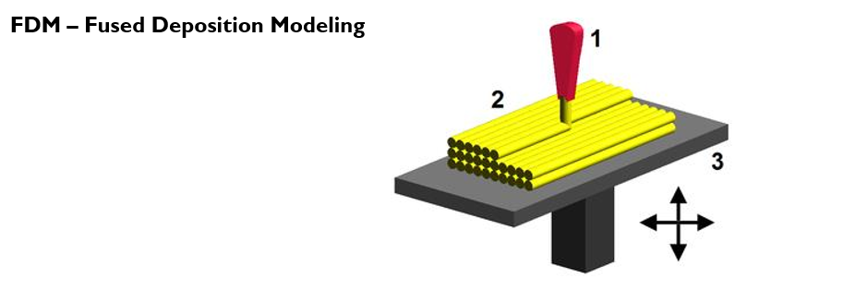

**Advantages:** Cheaper since uses plastic, more expensive models use a different (water soluble) material to remove supports completely. Even cheap 3D printers have enough resolution for many applications.

**Disadvantages:** Supports leave marks that require removing and sanding. Warping, limited testing allowed due to Thermo plastic material.

**SLA – Stereolithography**

Stereolithography is an additive manufacturing process which employs a vat of liquid ultraviolet curable photopolymer "resin" and an ultraviolet laser to build parts' layers one at a time. For each layer, the laser beam traces a cross-section of the part pattern on the surface of the liquid resin. Exposure to the ultraviolet laser light cures and solidifies the pattern traced on the resin and joins it to the layer below.

After the pattern has been traced, the SLA's elevator platform descends by a distance equal to the thickness of a single layer, typically 0.05 mm to 0.15 mm (0.002" to 0.006"). Then, a resin filled blade sweeps across the cross section of the part, re-coating it with fresh material. On this new liquid surface, the subsequent layer pattern is traced, joining the previous layer. A complete 3-D part is formed by this process. After being built, parts are immersed in a chemical bath in order to be cleaned of excess resin and are subsequently cured in an ultraviolet oven.

Stereolithography requires the use of supporting structures which serve to attach the part to the elevator platform, prevent deflection due to gravity and hold the cross sections in place so that they resist lateral pressure from the re-coater blade. Supports are generated automatically during the preparation of 3D Computer Aided Design models for use on the stereolithography machine, although they may be manipulated manually. Supports must be removed from the finished product manually, unlike in other, less costly, rapid prototyping technologies.

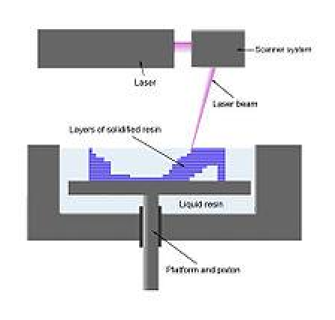

**Advantages and Disadvantages**

One of the advantages of stereolithography is its speed; functional parts can be manufactured within a day. The length of time it takes to produce one particular part depends on the size and complexity of the project and can last from a few hours to more than a day. Most stereolithography machines can produce parts with a maximum size of approximately 50×50×60 cm (20"×20"×24") and some, such as the Mammoth stereolithography machine (which has a build platform of 210×70×80 cm),[7] are capable of producing single parts of more than 2m in length. Prototypes made by stereolithography are strong enough to be machined and can be used as master patterns for injection molding, thermoforming, blow moulding, and various metal casting processes.

**SLS - Selective laser sintering:**

Selective laser sintering is an additive manufacturing technique that uses a high power laser (for example, a carbon dioxide laser) to fuse small particles of plastic, metal (direct metal laser sintering), ceramic, or glass powders into a mass that has a desired three-dimensional shape. The laser selectively fuses powdered material by scanning cross-sections generated from a 3-D digital description of the part (for example from a CAD file or scan data) on the surface of a powder bed. After each cross-section is scanned, the powder bed is lowered by one layer thickness, a new layer of material is applied on top, and the process is repeated until the part is completed. Because finished part density depends on peak laser power, rather than laser duration, a SLS machine typically uses a pulsed laser. The SLS machine preheats the bulk powder material in the powder bed somewhat below its melting point, to make it easier for the laser to raise the temperature of the selected regions the rest of the way to the melting point. Some SLS machines use single-component powder, such as direct metal laser sintering. However, most SLS machines use two-component powders, typically either coated powder or a powder mixture. In single-component powders, the laser melts only the outer surface of the particles (surface melting), fusing the solid non-melted cores to each other and to the previous layer. Compared with other methods of additive manufacturing, SLS can produce parts from a relatively wide range of commercially available powder materials. These include polymers such as nylon (neat, glass-filled, or with other fillers) or polystyrene, metals including steel, titanium, alloy mixtures, and composites and green sand. The physical process can be full melting, partial melting, or liquid-phase sintering. Depending on the material, up to 100% density can be achieved with material properties comparable to those from conventional manufacturing methods. In many cases large numbers of parts can be packed within the powder bed, allowing very high productivity. SLS is performed by machines called SLS systems. SLS technology is in wide use around the world due to its ability to easily make very complex geometries directly from digital CAD data. While it began as a way to build prototype parts early in the design cycle, it is increasingly being used in limited-run manufacturing to produce end-use parts. One less expected and rapidly growing application of SLS is its use in art.

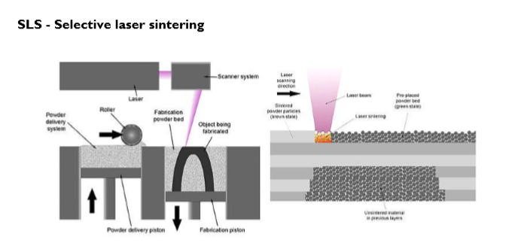

**Benefits:**

SLS has many benefits over traditional manufacturing techniques. Speed is the most obvious because no special tooling is required and parts can be built in a matter of hours. Since SLS can use most alloys, prototypes can now be functional hardware made out of the same material as production components. SLS is also one of the few additive manufacturing technologies being used in production. Since the components are built layer by layer, it is possible to design internal features and passages that could not be cast or otherwise machined. Complex geometries and assemblies with multiple components can be simplified to fewer parts with a more cost effective assembly. SLS does not require special tooling like castings, so it is convenient for short production runs.

**Table showing all available types of 3D Printers:**

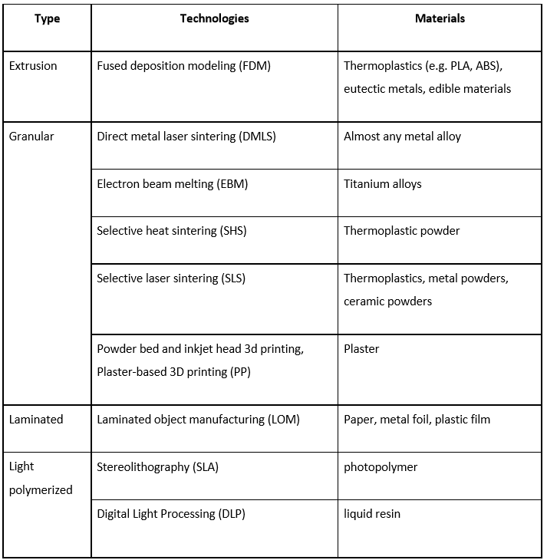

**APPLICATIONS**

Three-dimensional printing makes it as cheap to create single items as it is to produce thousands and thus undermines economies of scale. It may have as profound an impact on the world as the coming of the factory did....Just as nobody could have predicted the impact of the steam engine in 1750 or the printing press in 1450, or the transistor in 1950 . It is impossible to foresee the long-term impact of 3D printing. But the technology is coming, and it is likely to disrupt every field it touches.

Additive manufacturing's earliest applications have been on the tool room end of the manufacturing spectrum. For example, rapid prototyping was one of the earliest additive variants, and its mission was to reduce the lead time and cost of developing prototypes of new parts and devices, which was earlier only done with subtractive tool room methods (typically slowly and expensively). With technological advances in additive manufacturing, however, and the dissemination of those advances into the business world, additive methods are moving ever further into the production end of manufacturing in creative and sometimes unexpected ways. Parts that were formerly the sole province of subtractive methods can now in some cases be made more profitably via additive ones.

Standard applications include design visualization, prototyping/CAD, metal casting, architecture, education, geospatial, healthcare, and entertainment/retail.

3D printer came with immense number of applications. All the traditional methods of printing causes wastage of resources. But 3D printer only uses the exact amount of material for printing. This enhances the efficiency. If the material is very costly, 3d printing techniques can be used to reduce the wastage of material.

Consider printing of a complex geometry like combustion chamber of a rocket engine. The 3D printing will enhances the strength and accuracy of the object. Conventional methods uses parts by parts alignment. This will cause weak points in structures. But in the case of 3D printed object, the whole structure is a single piece.

3D printer has numerous application in every field it touches. Since it is a product development device, rate of production, customization and prototyping capabilities need to be considered.

**RAPID PROTOTYPING**

Rapid prototyping is a group of techniques used to quickly fabricate a scale model of a physical part or assembly using three-dimensional computer aided design (CAD) data. Construction of the part or assembly is usually done using 3D printing or "additive layer manufacturing" technology.

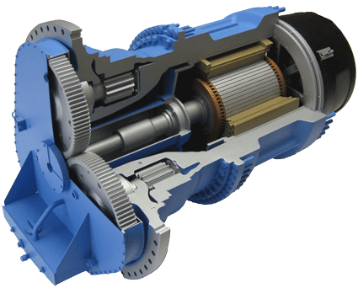

**Fig:6**

The first methods for rapid prototyping became available in the late 1980s and were used to produce models and prototype parts. Today, they are used for a wide range of applications and are used to manufacture production-quality parts in relatively small numbers if desired without the typical unfavourable short-run economics. This economy has encouraged online service bureaus. Historical surveys of RP technology start with discussions of simulacra production techniques used by 19th-century sculptors. Some modern sculptors use the progeny technology to produce exhibitions. The ability to reproduce designs from a dataset has given rise to issues of rights, as it is now possible to interpolate volumetric data from one-dimensional images. As with CNC subtractive methods, the computer-aided-design - computer-aided manufacturing CAD-CAM workflow in the traditional Rapid Prototyping process starts with the creation of geometric data, either as a 3D solid using a CAD workstation, or 2D slices using a scanning device. For RP this data must represent a valid geometric model; namely, one whose boundary surfaces enclose a finite volume, contain no holes exposing the interior, and do not fold back on themselves. In other words, the object must have an “inside.” The model is valid if for each point in 3D space the computer can determine uniquely whether that point lies inside, on, or outside the boundary surface of the model. CAD post-processors will approximate the application vendors’ internal CAD geometric forms (e.g., B-splines) with a simplified mathematical form, which in turn is expressed in a specified data format which is a common feature in Additive Manufacturing: STL (stereolithography) a de facto standard for transferring solid geometric models to SFF machines. To obtain the necessary motion control trajectories to drive the actual SFF, Rapid Prototyping, 3D Printing or Additive Manufacturing mechanism.

**MASS CUSTOMIZATION**

Mass customization, in marketing, manufacturing, call centers and management, is the use of flexible computer-aided manufacturing systems to produce custom output. Those systems combine the low unit costs of mass production processes with the flexibility of individual customization.



**Fig:6**

Mass customization is the new frontier in business competition for both manufacturing and service industries. At its core is a tremendous increase in variety and customization without a corresponding increase in costs. At its limit, it is the mass production of individually customized goods and services. At its best, it provides strategic advantage and economic value.

Mass customization is the method of "effectively postponing the task of differentiating a product for a specific customer until the latest possible point in the supply network." (Chase, Jacobs & Aquilano 2006, p. 419). Kamis, Koufaris and Stern (2008) conducted experiments to test the impacts of mass customization when postponed to the stage of retail, online shopping. They found that users perceive greater usefulness and enjoyment with a mass customization interface vs. a more typical shopping interface, particularly in a task of moderate complexity. From collaborative engineering perspective, mass customization can be viewed as collaborative efforts between customers and manufacturers, who have different sets of priorities and need to jointly search for solutions that best match customers’ individual specific needs with manufacturers’ customization capabilities (Chen, Wang & Tseng (2009)).

With the arrival of 3D printer, we are able to customize any products we want. Consider you are in a shop to buy a spectacle. The only choice you have is to select a model from the shop. If you didn’t like any model, you will probably go to another shop. By the implementation of 3d printed spectacles, you are provided with power for creating any spectacle in the world with just the CAD model. Many implementations of mass customization are operational today, such as software-based product configurators that make it possible to add and/or change functionalities of a core product or to build fully custom enclosures from scratch.

**AUTOMOBILES**

In early 2014, the Swedish supercar manufacturer, Koenigsegg, announced the ‘One:1’, a supercar that utilises many components that were 3D printed. In the limited run of vehicles Koenigsegg produces, the ‘One:1’ has side-mirror internals, air ducts, titanium exhaust components, and even complete turbocharger assembles that have been 3D printed as part of the manufacturing process

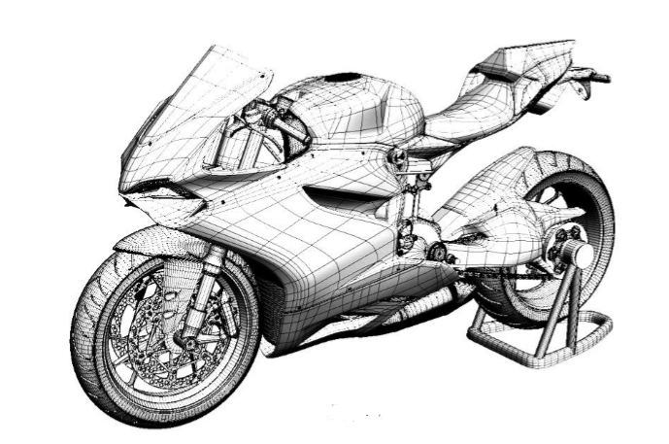

**Fig:7**

An American company, Local Motors is working with Oak Ridge National Laboratory and Cincinnati Incorporated to develop large scale additive manufacturing processes suitable for printing an entire car body. The company plans to print the vehicle live in front of an audience in September 2014 at the International Manufacturing Technology Show. Produced from a new fibre-reinforced thermoplastic strong enough for use in an automotive application, the chassis and body without drivetrain, wheels and brakes weighs a scant 450 pounds and the completed car is comprised of just 40 components, a number that gets smaller with every revision.

Fig.12 shows the 3D CAD model of a bike, actually of a 3D printed scale replica created by designer Jacky Wan from Redicubricks. The 3D printed bike is made of over 40 individual pieces and Wan details his print and build process over on Ultimakers blog. He even includes a link to his 3D files so you can build one yourself if you think you’re up to it. The project is certainly not for beginners. When designing the bike replica, Wan imposed several goals on himself; He wanted to maintain the external looks of the bike, all parts needed to snap fit together to make gluing easier, keep seams and striation to a minimum and everything needed to print on his Ultimaker: Original. Of course 3D printing a realistic motorcycle replica wasn’t going to make it easy for him to meet to those goals.

**WEARABLES**

San Francisco-based clothing company, Continuum is among the first to create wearable, 3D printed pieces. Customers design bikinis on Continuum’s website, specifying their body shapes and measurements. The company then uses nylon to print out each unique order. Founder Mary Huang believes that this intersection of fashion and technology will be the future because it “gives everyone access to creativity.”

This year, architect Francis Bitonti and fashion designer Michael Schmidt collaborated to make a dress for burlesque diva Dita Von Teese. She wore the garment to the Ace Hotel in March for a convention hosted by online 3D printing marketplace, Shapeways. The dress consists of 2,500 intersecting joint pieces that were linked together by hand. The finishing touches a black lacquer coating and 12,000 hand-placed Swarovski crystals reflect Schmidt’s iconic glam that attracts a clientele of Madonna, Rihanna, Lady Gaga, and the like. British designer Catherine Wales is making moves too. She is best known for her Project DNA collection, which includes avant-garde 3D printed masks, accessories, and apparel, all printed with white nylon. The eccentric shapes of her garments reflect that 3D printed clothing is still in its early stages. Today, the materials and technologies used for 3D printing still dictate and affect garment design.

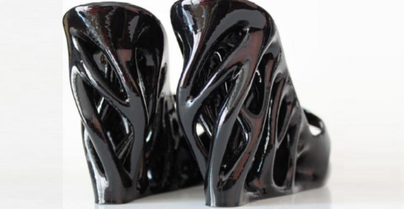

**Fig:8**

Dutch designer Iris Van Herpen has already put this new material to the test in her Voltage Haute Couture collection, which raised eyebrows at Paris Fashion Week in January 2013. A frontrunner in the realm of futuristic fashion design, Van Herpen has been taking her 3D printed dresses and shoes to the runways since 2010. Still, she admits that there are challenges associated with incorporating a new medium into the manufacturing process. “I always work together with an architect because I am not good with the 3D programs myself,” she said.

The idea of custom design has mass appeal and marketability. Who doesn’t want to wear a one-of-a-kind, perfectly tailored piece? Perhaps the teenage girl of the future won’t have to suffer the social agony of showing up to a school dance wearing the same dress as her archenemy.

**CHAPTER 2:**

**SURVEY OF TECNOLOGIES**

**SURVEY OF TECHNOLOGY**

In 3D printing technologies, the process involves certain steps which are firstly a CAD based model is created and then converted to a Stereo-lithographic file which is in (.STL) .This files breaks down the surface into logical series of triangles which represents a part of the surface of a 3D model that is then used for the slicing algorithm. The STL file slices the model into thin cross-sectional layers that allowed the required model to be 3D printed.

**Feed Mechanism or Types of Technologies**

1. **Binder Jetting**: Creating object by joining the powdered material through jet deposition of binding agent, examples of Materials are metal, polymer, and ceramic. Developers (Country) are: exOne (US), Voxel Jet (Germany) 3D System (US).
2. **Material Jetting:** Build parts by set down small droplets of the filament, which are then cured by exposure to light (UV) and it has a high resolution of about 16 microns of layer height. Material: photopolymer and wax. Developers (Country) are: stratasys (US), LUXeXcel (Netherlands), 3D system (US)
3. **Direct Energy Deposition:** Focused thermal energy is used for fusing material to builds part as they are deposited on a substrate. Materials are powder and wire. Developer’s (countries) are: DM3D (US), NRC-IMI (Canada), Irepa Laser (France), Trumpf (Germany)
4. **Powder Bed Fusion:** creates object by using thermal energy to fuse regions of a powder bed, Materials used are metal, polymer, ceramic. Developers (country): EOS (Germany), Renishaw(UK), Matsuura Machinery (Japan), ARCAM(Sweden) 3D system (US), Phenix System (France).
5. Direct Metal Laser Sintering (DMLS): forming an object by melting and fusing metal powder using a focused laser beam in a chamber of inert gas
6. Electron Beam Melting (EBM): It fabricates an object uses an electron beam that melts powder inside a vacuum.
7. Selective Heat Sintering (SHS): It applies heat using a thermal print head to layers of thermoplastic powdered using which cures the powder.
8. Selective Laser Melting (SLM): this process melts a metal powder forming a melt pool by using a laser process held in inert gas chamber and then roller adds the material again on the top of it and the same procedure is repeated to build an object.
9. Selective Laser Sintering (SLS): The process is similar to the SLM where a laser sinters a powdered material and a roller adds new layer of material to form the part. The difference is that material is heated below the melting point until this particles fuse with each other.

1. **Sheet Lamination:** build parts by trimming sheets of material and binding them together in layers. Materials used are Hybrid, metallic and ceramic. Developers (Country) are: fabrisonic (US), CAM-LEM (US).
2. Laminated Object Manufacturing (LOM): this process works by adding layers of adhesive coated paper, plastic or metal which are non-toxic. Each layer or sheet of thin material are cut to shape with a laser cutter and then successively glued together
3. Ultrasonic Additive Manufacturing (UAM): It uses the sheet lamination process where thin sheets of metal are joined together until the object is build. An ultrasonic welding is used to bond the sheets and then a CNC mill cuts the excess material.
4. **Light Photopolymerization**: build parts by using light to selectively curing layers of SSS Developer’s countries are 3D system (US), Encision TEC (Germany) DWS Sri (Italy) Lithoz (australia).
5. Digital Light Processing (DLP): an image of the object is projected in layers into a vat of photopolymer that reacts to the projecting light in order to cure and harden the desired part.
6. Stereo-lithography (SLA): a liquid photopolymer resin is melt using a beam of UV light sent from a laser which causes the resin in contact to react and solidify.
7. **Extrusion:** creating objects by depositing material through a heated nozzle to build a layer that instantly harden so the next layer bond on top and this process is repeated until an object is formed also called Fused Deposition Modeling (FDM). Material is polymer Developer (Country): Stratasys (US), Delta Micro factory (China), 3D systems (US).

**CHAPTER 3:**

**REQUIREMENTS AND ANALYSIS**

**Problem Definition**

## Problems With 3D Printing and How to Fix Them:

**1. Output/Quality Problems with 3D Printing.**

In some ways, this is the most basic thing, but there are many quality-related problems with 3D printing today:

* Fragile, delaminated FDM (fused deposition modelling) parts
* Low-resolution output
* Materials

Now, to be fair, the materials are defined by what can be extruded, squirted, or melted, but this is not based on their application or final use. And even though there are some examples of multi materials, it’s typically only two at a time. So we’re constraining ourselves.

But I don’t want to constrain my imagination. I want a printer that enables me to create materials that didn’t exist outside of the printer. I want one that creates metal alloys in the box.

Let me give you an example here, which will either crystallize the problem or make you wonder how old I am: Remember Shrinky Dinks? You’d draw these designs, put them in the oven, shrink them, and then . . . realize the result wasn’t really worth having.

But here’s the point: We need to shift the emphasis in 3D printing from “Look, I made something!” to “Look what I made!” It has to be consistently high quality, using great materials, and producible in no other way.

**2. The Process Is Unreliable. Too Much 3D Printer Troubleshooting**

The complexity of just getting the process to work is often daunting, and it involves too much fiddling with formats, parameters, and mechanical adjustments.

You all know the joke by now:

Why are 3D printers transparent?

So you can watch your build fail!

I know it’s so that we can see what’s going on, but mostly it’s so we can intervene when the process breaks down.

It’s to the point where people install cameras to watch their printers! Can you imagine standing there and staring at a 2D printer to make sure it was behaving properly? Of course not.

It is time to shift from the obsession with 3D printers and 3D printing and focus on what is being 3D printed. Who cares if I have a great 3D printer, and I’m having a great time 3D printing? What I want is the output.

I look forward to the day when 3D printers are not transparent, but the path from design to fabrication is clear. When the whole process is so reliable and high quality that 3D printing experiences the wonderful fate of any successful technology: ubiquity and invisibility. A boring, black box.

The overall goal should be to move to “one-click-print” reliability. To get there, what’s needed is the equivalent of PostScript and the LaserWriter, which were the catalysts for reliable desktop publishing. That’s what it’s going to take to get some real traction on this “revolution.”

**3. The Workflow.**

The workflow is old and outdated, and it’s still based on the classic linear approach:

* Human: Design
* Computer: Document and Analyze

The 3D-printing workflow usually doesn’t take advantage of generative design or other recent breakthroughs. The problem with the current workflow is that, first, designers are drawing stuff, and then the robot is drawing stuff again in the 3D printer.

That means people are still designing the same old parts and then somehow expecting the 3D-printed outcome to be unique. As long as people’s drawing capabilities are in the way, they’re squandering the power of 3D printing.

It would actually be better to delegate more of the actual design to the computer. In fact, if designers fully adopted that mindset, they could permit the software to come up with designs more elaborate than anything they could draw.

Using the old mindset, where designers have to do all the work, the outcome of their efforts will always be restricted by their limitations of time, money, and patience. They’re often limited to just one or two choices at a time, and then just printing the better one, not the best possible design.

Here’s a critical mindset switch: Designers have to stop thinking of their computers as mere drawing tools. They’re not just for execution. They should expand exploration.

**4. The Target: It’s Wrong.**

The fourth lamentation is that people have been aiming at the wrong target with their 3D-printing efforts.

They’ve been happy creating prototypes, replacement parts, and trinkets; but what they should be focused on are final parts and creating novel solutions to higher-level problems.

In order to reach this new target, it’s important to look at 3D printing holistically, through four facets of additive manufacturing: parts, system, materials, and process.

In other manufacturing processes, you could separate these four ideas and optimize each separately. But in 3D printing, they all come together because they all affect each other. The best way to achieve assembly function is through materials. Springs, levers, hinges, and dampers can be achieved, not just via individual parts, but also through clever in-process materials. Understanding the relationship between interacting elements is key.

**REQUIREMENTS ANALYSIS**

1.What’s the layer thickness?

Answer:

Layer thickness is typically used to describe the surface finish of a part. While the thickness of a layer is often better at lower layer heights, the issue is that the roughness of a surface is not standard in relation to the layer height.

2.How long did it take to print?

Answer:

Maximum speed is a hard metric to quantify, particularly across different printers. Again, there’s not enough information for us to really understand how these printers will perform when producing parts. Not only do the standard variables impact print time, so too do factors like geometry and orientation of the part.

For instance, a taller part will take more time than one oriented closer to the build plate because there are more layers to print. Also, the way that an object is oriented and supported will change the time it takes to print the part.

A common benchmark is how fast a printer can produce a one-inch cube. The problem with that example is that it’s very specific. Unless you’re a dice manufacturer, one-inch cubes aren’t a great way to estimate how long your part will take to print.

3. What is the accuracy of your system?

Answer:

Accuracy isn’t included in the chart in the introduction, but it is something that a few 3D printer companies have been publishing recently. The mistake that a lot of 3D printer buyers make is assuming that XY resolution or layer thickness will determine the accuracy of the final part.

The truth is that global accuracy is hard to determine, largely because it can be impacted by length, geometry, and orientation.

**4. How does it know what to print?**

**Answer:**

Computer models are created on the computer and then run through a slicing program to generate the machine coding that moves the print head. Computers are either connected directly to the 3D printer or an SD card is inserted to transfer the directions to the machine.

5. What are the Limitations of your System?

Answer:

* Surface texture is generally too rough.
* Materials have low heat deflection temperatures.
* Materials generally have low strengths.
* Material prices are far too high restricting the growth of the market.
* Parts are generally not as dense as parts made by CNC and other processes.
* Colour is only possible with Mcor and Zcorp and these do not provide for functional parts.
* It is too difficult to design for 3D printing.
* The software tool-chain is too complex.
* It is too difficult to 3D model.
* Manufacturing complex parts or organic parts needs a lot of 3D modeling training.
* 3D scanners are not good enough and create holes in final files.
* Re-meshing software is not good enough.
* Printers are not large enough.
* Printers are not fast enough.
* Build quality and up-time on desktop systems is terrible.
* Industrial AM machines are too expensive.

6. Is 3d printing expensive?

Answer:

In general, you could say that **3D printing** small objects is cheap and **3D printing** large objects is **expensive**. Prices go up exponentially as the object size increases.

The 3D Printer, which I have planned to build is costing me 15,000 to 20,000 Inr.

7. What are the benefits of 3D printing?

Answer:

Like most emerging technologies, 3D printing offers benefits in a lot of areas. These include improvements in financial, logistical, healthcare, creative and environmental areas.

For one, the technology allows for endless customization with regards to design and material. One notable example of this benefit is in the healthcare sector. Complex prosthetic limbs can be produced precisely to individual needs for a much lower price.

8. Can I make money with a 3d printer?

Answer:

If you can dedicate yourself to achieve the goal its one of the fast growing manufacturing sectors in India.

3D printing is required in many college research programs and prototyping in companies.

Average cost for printing is 300 per hr in market. A small 1*1*1 size cube takes around 15 minutes to print depending up on its quality and the filament used (PLA or ABS plastic).

One of the easiest ways to make money with a 3D printer is to offer the printer as a commercial service or to sell items that are made with it. Businesses and individuals often want objects produced through 3D printing, but don't have the equipment. Additionally, as a skilled designer, you can make items and sell them.

9. Can I build my own 3D printer?

Answer:

Yes, you can either buy a 3D printer kit or design and build one entirely from scratch. Typically, kit 3D printers are cheaper because the manufacturer saves assembly costs. Below, you see a kit of a Printrbot Metal, which can be assembled and calibrated in just a day.

If you’re interested in building your own 3D printer, take a look at our overview of the [best cheap DIY printer kits](https://all3dp.com/diy-3d-printer-kit/) and at our roundup of the [best Prusa i3 DIY kits](https://all3dp.com/best-reprap-prusa-i3-kit-3d-printer-buy/).

Fact: 12-year-old Amogh designed and put together [a working 3D printer out of LEGO, K’NEX and a 3D pen](https://all3dp.com/working-lego-3d-printer-build-12-year-old/). He then uploaded the design and instructions to Instructables for other people to see and replicate.)

10. How can I connect with other people doing 3D printing?

Answer:

If you are looking to meet up with other people doing 3D printing, there are a few different routes you can take. A great place to find people who are interested in the same things as you is [www.meetup.com](https://www.meetup.com/), a social platform designed especially for that purpose.

Another great place is your local [Fab Lab](https://www.google.com/#q=local+fablab). There, you are bound to meet other makers.

**SOFTWARE REQUIREMETS**

**1.Fusion 360(For 3D Model):**

## 1. What is Fusion 360?

Autodesk Fusion 360 is a collaborative, cloud-enabled design platform that has all of the features mentioned above and more. It includes all the tools you need to go from design to fabrication, without having to leave the tool.

Let’s say you want to design a chair. First, we need to create the design from scratch. As you can probably imagine, a chair has its fair share of geometric and ergonomic features. In Fusion 360, you can create these features in its parametric and sculpting environment. We can then run tests in the simulation environment to ensure it can withstand the necessary force. After the validation process, toolpaths can be made to machine the legs in the CAM environment. Finally, we can watertight the body and send it out to manufacturing.

## 2.Will It Work With My Current Tool Set?

Fusion 360 works alongside your current software. If you want to create organically shaped models not supported with your current 3D modeler, you can do so in Fusion 360’s sculpting environment. Further, if you want to create toolpaths for your model so the mill or lathe can cut your part, you can use Fusion 360’s CAM environment.

Importing and exporting from Fusion 360 is also a breeze because it supports various file types, including SolidWorks and Inventor files. Take a look at all the [different file types supported in Fusion 360](https://knowledge.autodesk.com/support/fusion-360/troubleshooting/caas/sfdcarticles/sfdcarticles/How-to-import-or-open-a-file-in-Autodesk-Fusion-360.html).

## 3.Why Is the Cost So Low?

Fusion 360 has a low, competitive price. In fact, for hobbyists and enthusiasts, it’s free. The Fusion 360 team is looking to start-ups and entrepreneurs to have the tools they need to run their business successfully without big start-up costs. There really is no reason to not test out Fusion 360 and see how it works for you.

## 4.What Makes Fusion 360 So Important?

Fusion 360 is important because it’s a utility software tool that can do everything in one place. You can crate 3D designs, collaborate, manage data, create toolpaths, run simulation to validate your designs, and much more. It is a next generation design tool that will continue to have a huge impact on the community.

Watch below for a deeper understanding of Fusion 360 and how to get started.

**2. Ultimaker Cura (Convert 3D Model to GCode):**

**Cura** is an open source application. It was created by [David Braam](https://en.wikipedia.org/w/index.php?title=David_Braam&action=edit&redlink=1) who was later employed by [Ultimaker](https://en.wikipedia.org/wiki/Ultimaker" \o "Ultimaker), a 3D printer manufacturing company, to maintain the software. Cura is available under [LGPLv3](https://en.wikipedia.org/wiki/LGPL) license. Cura was initially released under the [open source](https://en.wikipedia.org/wiki/Open-source_software) [Affero General Public License version 3](https://en.wikipedia.org/wiki/Affero_General_Public_License" \o "Affero General Public License), but on 28 September 2017 the license was changed to [LGPLv3](https://en.wikipedia.org/wiki/LGPL). This change allowed for more integration with third-party CAD applications. Development is hosted on [GitHub](https://en.wikipedia.org/wiki/GitHub). Ultimaker Cura is used by over one million users worldwide, handles 1.4 million print jobs per week, and is the preferred 3D printing software for Ultimaker [3D printers](https://en.wikipedia.org/wiki/3D_printing), but it can be used with other printers as well.

**Technical Specification:**

Ultimaker Cura works by slicing the user’s model file into layers and generating a printer-specific [g-code](https://en.wikipedia.org/wiki/G-code). Once finished, the g-code can be sent to the printer for the manufacturing the physical object.

The open source software is compatible with most desktop 3D printers can work with files in the most common 3D formats such as [STL](https://en.wikipedia.org/wiki/STL_(file_format)), [OBJ](https://en.wikipedia.org/wiki/Wavefront_.obj_file), [X3D](https://en.wikipedia.org/wiki/X3D), [3MF](https://en.wikipedia.org/wiki/3D_Manufacturing_Format) as well as image file formats such as [BMP](https://en.wikipedia.org/wiki/BMP_file_format), [GIF](https://en.wikipedia.org/wiki/GIF), [JPG](https://en.wikipedia.org/wiki/JPEG), and [PNG](https://en.wikipedia.org/wiki/Portable_Network_Graphics).

**Major software versions:**

7-Jun-2016 Ultimaker announced the new Cura major release 2.1.2, superseding the previous 15.04.6 version (note the non-sequentiality in the major version numbers).

Sept 2016 Version 2.3 was a major release. It includes new printing profiles, slicing features, as well as increasing speed. It also supported the dual extrusion possible with the Ultimaker 3 model

17-Oct-2017 The current major version, Version 3.0 updated the user interface and allowed for CAD integration. This was the first version with plugin support.

Nov 2017 - Cura Connect was released to enable users to control, monitor, and configure a group of network-enabled 3D printers from a single interface.

October 2018 - Beginning with version 3.5, all files are saved in the 3MF format for improved compatibility with other 3D software. Hotkeys were introduced as well as a searchable profile guide.

Nov 2018 - Version 3.6 introduced material profile support for materials made by major manufacturers such as [BASF](https://en.wikipedia.org/wiki/BASF), [DuPont](https://en.wikipedia.org/wiki/DuPont), [Clariant](https://en.wikipedia.org/wiki/Clariant), and other members of the Materials Alliance Program consortium.

**Note:** starting with Cura version 3.1, USB connected printers are supported. If you have a USB only printer or wish to use USB connectivity, Cura 3.1 or later must be used.

March 2019 - Version 4.0 released. Significant changes to the user interface were made. In support of plugin capabilities, a star-based rating system was incorporated to allow users to rate plugins. Cloud-backup functionality was added as well as support for more third-party printers.

**Plugins:**

Release 3.0 introduced plugin capability. Users can develop their own plugins or use plugins commercially available. Plugins simplify workflow for users by allowing them to quickly perform tasks like opening a file from a menu or exporting a file from an application. Starting with Release 4.0, users can rate plugins using a star system.

Current plugins include: SolidWorks, Siemens NX, HP 3D Scanning, Make Printable, AutoDesk Inventor.

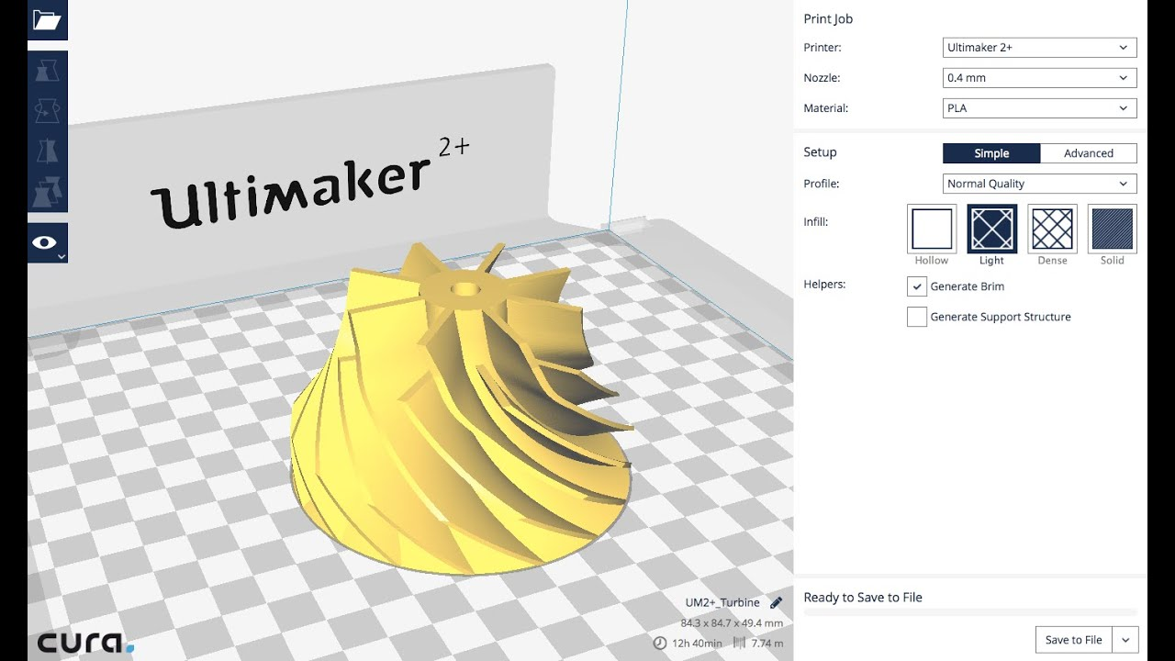

**3. XLoader**

The XLoader Application is used for uploading HEX File into Arduino (Microcontroller).

Microsoft Windows Tool for Flashing CC01 and CR03(Computer 01 and Computer 03) using IP01.

[[](https://github.com/xinabox/xLoader/blob/master/images/xLoader.gif)](https://github.com/xinabox/xLoader/blob/master/images/xLoader.gif)

### **Flashing Steps:**

1. Download [xLoader.zip](https://github.com/xinabox/xLoader/releases/latest) file.
2. Virus Check the xLoader.zip file
3. Unzip the xLoader.zip file
4. Connect **☒P01** and **CC01/CR03** together
5. Insert **IP01** and **CC01/CR03** into an available USB port
6. Wait for eventual drivers to be installed, if driver installation fail, goto [USB Driver](https://github.com/xinabox/xLoader#usb-driver)
7. Execute the xLoader.exe file
8. Choose Firmware. There is a .hex file included in the install folder. You can also download a [specific radio ID pairs](https://github.com/xinabox/xLoader/releases/latest).
9. Choose your COM port. If no COM port is available, goto [USB Driver](https://github.com/xinabox/xLoader#usb-driver)
10. Click Upload
11. Wait for the text Uploading... to be replaced by <nnnn> bytes uploaded
12. Unplug **P01** and **CC01/☒CR03**

### **USB Driver:**

If you have issues with USB drivers for the **IP01**, then go here [IP01](https://github.com/xinabox/xIP01), and install the driver from the drivers folder.

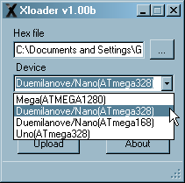                                 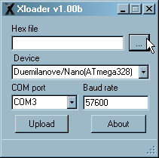

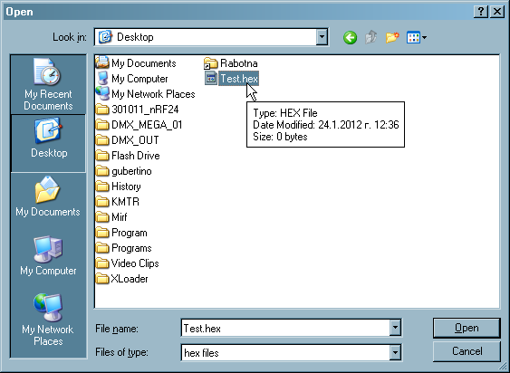

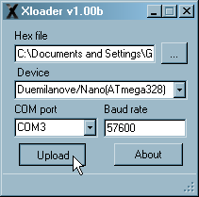

# **4. PRONTERFACE**

Pronterface is a 3D printing host – a program that allows direct control of 3D printers (including printing a sliced gcode) through a USB cable. Pronterface is a part of Printrun, a free, open-source software suite, licensed under the GNU General Public License, version 3.

When we need to control of our JellyBOX using our computer, be it for troubleshooting, development, or for show, we use Pronterface.

Pronterface is a 3D printing host– a program that allows direct control of 3D printers (including printing a sliced gcode) through a USB cable.

Pronterface is a part of Printrun, a free, open-source software suite, licensed under the GNU General Public License, version 3. (Yay!)

What sets Pronterface apart is its large and comfortable command line interface, and small footprint (it takes no space on your computer.) The interface is barely functionalist, but also highly functional.

PS: Also, great simple macros. That’s your homework, you overachievers.

**Steps: To Install Download, Install and Configure:**

1. Head over to <http://www.pronterface.com/#download>
2. “Windows & OSX binaries” (unless you’re on Linux, but then you don’t need this tutorial)  
   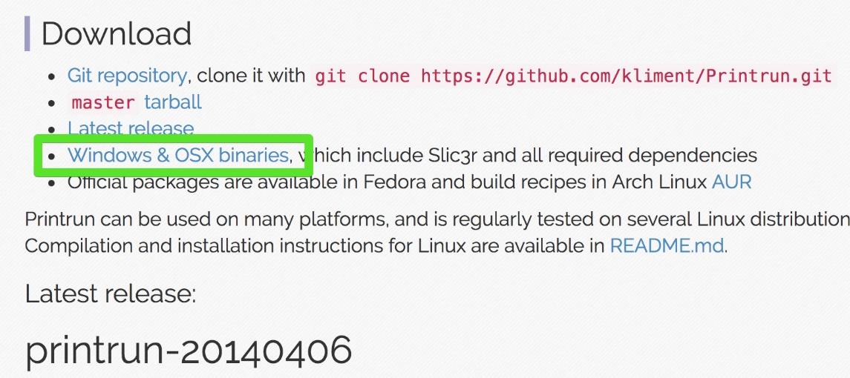
3. Download the latest Mac or PC .zip archive  
   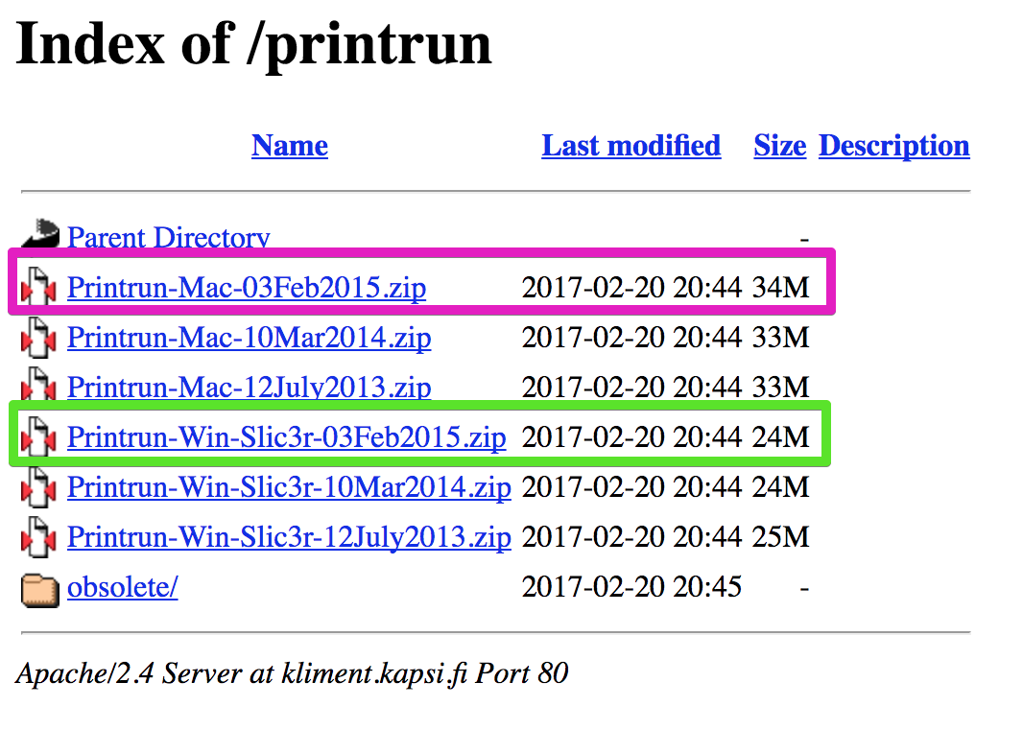
4. Unzip the archive (double click)
5. On both platforms, Pronterface simply runs from where ever you put it. On Windows, I suggest creating a folder ‘Portable Applications’ on your Desktop. On Mac, I suggest dragging the app into your Applications folder just like all the other programs.
6. Done!  
   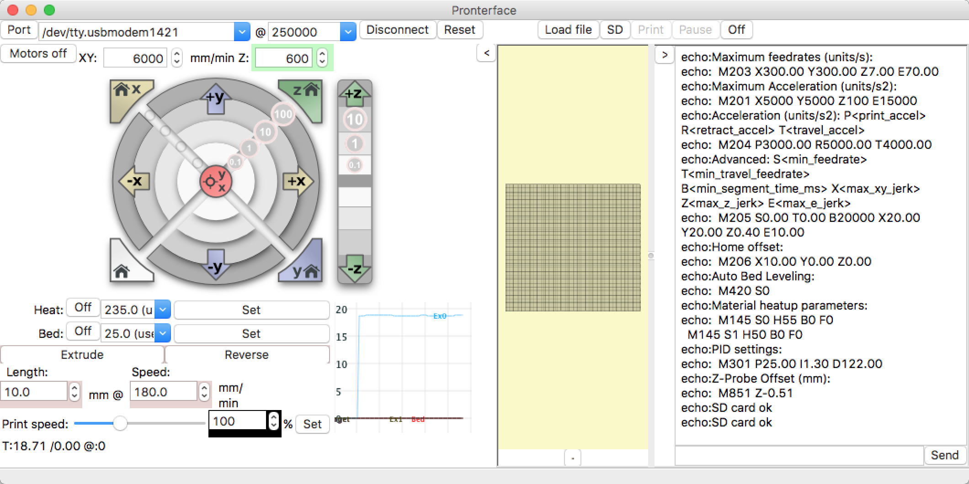

**Requirements to Run all the Software application in Laptop/Pc:**

**Operating systems:**

* Windows Vista or higher, 64 bit
* Mac OSX 10.11 or higher, 64 bit
* Ubuntu 14.04 or higher, 64 bit
* Intel Iris Plus Graphics 650 1536 MB
* Intel Iris Graphics 550 1536 MB
* Intel Iris Plus Graphics 640 1536 MB
* Intel Iris 550 1536 MB
* Intel HD Graphics 515 1536 MB
* Intel Iris Graphics 540
* Intel HD Graphics 515

**System Requirements:**

* RAM: 2GB, 8GB or more recommended
* Disk Space: 2.5GB, 20GB or more recommended
* Video Card (GPU): NVidia, AMD, or Intel, post 2011. 512MB video memory, 8GB or more recommended.
* Screen Resolution: 1280 x 1024 minimum, 1920 x 1080 or more recommended.
* CPU: AMD or Intel, post 2011.
* Network: Ethernet or wireless connectivity to Local Area Network
* Installation: Broadband Internet connection
* Browser for Online Documentation: Google Chrome, Firefox, Internet Explorer 11 or above
* Connectivity: USB, ETHERNET, WI-FI.

**HARDWARE REQUIREMENTS**

**(1) Arduino Mega 2560:**

Arduino is an open-source physical computing platform based on a simple i/o board and a development environment that implements the [Processing](http://www.processing.org/)/[Wiring](http://wiring.org.co/) language. Arduino can be used to develop stand-alone interactive objects or can be connected to software on your computer (e.g. Flash, Processing, MaxMSP). The open-source IDE can be [downloaded](http://arduino.cc/en/Main/Software) for free (currently for Mac OS X, Windows, and Linux).

The Arduino Mega is a microcontroller board based on the ATmega2560. It has 54 digital input/output pins (of which 14 can be used as PWM outputs), 16 analog inputs, 4 UARTs (hardware serial ports), a 16 MHz crystal oscillator, a USB connection, a power jack, an ICSP header, and a reset button. It contains everything needed to support the microcontroller; simply connect it to a computer with a USB cable or power it with a AC-to-DC adapter or battery to get started. Never fear for accidental electrical discharge, either since since the Mega also includes a plastic base plate to protect it!

The Mega 2560 R3 also adds SDA and SCL pins next to the AREF. In addition, there are two new pins placed near the RESET pin. One is the IOREF that allow the shields to adapt to the voltage provided from the board. The other is a not connected and is reserved for future purposes. The Mega 2560 R3 works with all existing shields but can adapt to new shields which use these additional pins.

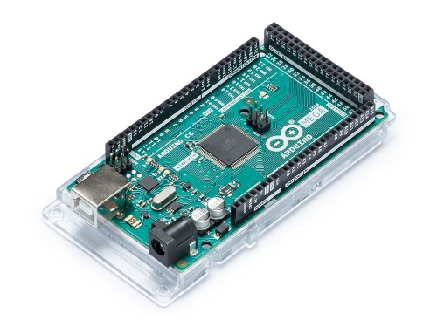

**ARDUINO MEGA 2560**

|  |  |
| --- | --- |
| Microcontroller | [ATmega2560](http://www.atmel.com/Images/Atmel-2549-8-bit-AVR-Microcontroller-ATmega640-1280-1281-2560-2561_datasheet.pdf) |
| Operating Voltage | 5V |
| Input Voltage (recommended) | 7-12V |
| Input Voltage (limit) | 6-20V |
| Digital I/O Pins | 54 (of which 15 provide PWM output) |
| Analog Input Pins | 16 |
| DC Current per I/O Pin | 20 mA |
| DC Current for 3.3V Pin | 50 mA |
| Flash Memory | 256 KB of which 8 KB used by bootloader |
| SRAM | 8 KB |
| EEPROM | 4 KB |
| Clock Speed | 16 MHz |
| LED_BUILTIN | 13 |
| Length | 101.52 mm |
| Width | 53.3 mm |
| Weight | 37 g |

**(2) Ramps 1.4**

RepRap Arduino Mega Polulu Shield, or RAMPS, is a board that serves as the interface between the Arduino Mega — the controller computer — and the electronic devices on a RepRap 3D printer. The computer extracts information from files containing data about the object you want to print and translates it into digital events, like supplying a voltage to a specific pin.

It takes many, many such pins turning on and off to tell a printer what to do. Unfortunately, the Mega doesn’t have enough power to actually operate the printer’s hardware.

That’s where the RAMPS board comes in. It organizes and amplifies the information coming from the Mega so that they’re properly directed down the correct channels.

For example, if the hot end carriage needs to move one step to the left, the RAMPs board routes the signals from the Mega to the X-axis stepper motor via the appropriate pins and wires.

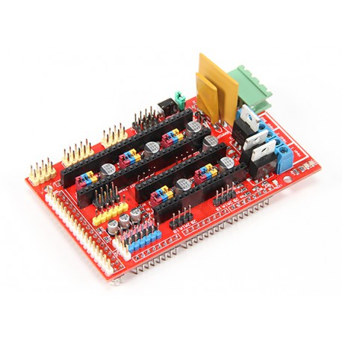

**RAMPS 1.4**

**(3) Extruder:**

The extruder is the part that thrusts out and feeds the plastic filament (or any other filament) into the ‘hot-end’. Extruders are typically incorporated into the hot-end, however in some types it can be remote, pushing the filament through a tube, called a Bowden cable, into the hot-end. In some types a dual extruder is used, which provides the ability to print two different materials at the same time. This added feature result in increased price, as it requires an extra extruder, and hot end.

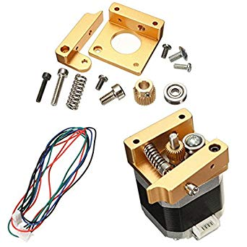

**1.75 Extruder**

**(4) Hotend (0.4):**

The hot-end is composed of a heat source, a temperature sensor, and an extrusion tip where plastic filament is fed though to deposit molten material, it is often confused with the extruder. The hole in the slot may range in size, typically between 0.2mm and 0.8mm. The smaller the nozzle, the more detailed the print, but the longer it takes for the thinner layers to stack up.

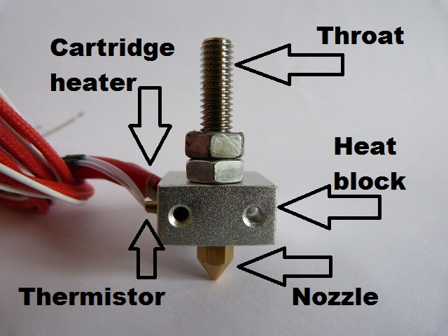

**0.4 Hotend**

**(5) Print Bed (Tray)**

This is the flat surface where the 3D models are layered during printing. The print bed may be ambient or heated Depending on the filament types used in the printer. Heated print beds are used to keep the printed section of the print warm during the layering process to prevent warping.

This print be used is of Aluminium Plates used for making the overall Framework of the 3D Printer.

**(6) A4988 pins:**

The A4988 is a microstepping driver for controlling bipolar stepper motors which has built-in translator for easy operation. This means that we can control the stepper motor with just 2 pins from our controller, or one for controlling the rotation direction and the other for controlling the steps.

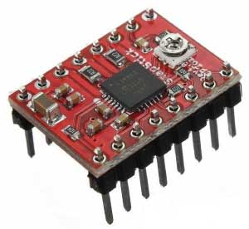

The Driver provides five different step resolutions: full-step, haft-step, quarter-step, eight-step and sixteenth-step. Also, it has a potentiometer for adjusting the current output, over-temperature thermal shutdown and crossover-current protection.

Its logic voltage is from 3 to 5.5 V and the maximum current per phase is 2A if good addition cooling is provided or 1A continuous current per phase without heat sink or cooling.

**(7) 3D Printer filament :**

3D printing filament is the [thermoplastic](https://en.wikipedia.org/wiki/Thermoplastic) [feedstock](https://en.wikipedia.org/wiki/Feedstock) for [fused deposition modeling](https://en.wikipedia.org/wiki/Fused_deposition_modeling) [3D printers](https://en.wikipedia.org/wiki/3D_printing). There are many types of filament available with different properties, requiring different temperatures to print.[[1]](https://en.wikipedia.org/wiki/3D_printing_filament#cite_note-1) Filament is available in two standard diameters; 1.75 and 2.85 mm/3 mm.

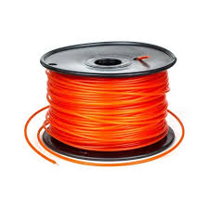

**1.75 3D Printer filament**

**(8). PTFE Tube:**

Polytetrafluoroethylene (PTFE) is a synthetic material, similar to Teflon (and closely related to it). Thanks to their low friction coefficient, tubes from this material are used to guide filament in all Original Prusa i3 printers. Not all the tubes are the same, multi-material printers often require narrow and more precise tubes, than the single-material printer. Before your order or make a new tube, make sure you have the correct dimensions.

**In general, we distinguish between :**

A) the tubes for the hotend, which are inside the extruder (common for all printers)

B) the tubes guiding the filament to the extruder (mostly for the multi-material printers)



**PTFE Tube**

# **(9) DVD Stepper Motor Board:**

* This stepper motor board is used for movement and printing the object in X an Y axis respectively.
* DVD stepper motor control board 2 phase 4 wire x2.
* can be used for making mini pen engraver machine,3d printer and laser engraver…

**(10) Floppy Disk Spindle Motor Board:**

* This spindle motor board is used for movement of or printing the object in Z axis respectively.

**(11) 12 volts SMPs:**

Power supplies, or PSUs (power supply units), are usually clunky metal boxes with a row of screw terminals or a bundle of wires at one end and a fan on the side. When you wire them up to your printer and plug them in, they seem to magically make things work. But what do they actually do?

PSUs tend to contain a transformer (or a series of transformers), which receives the 110 to 240 volts from the wall and steps them down to a more reasonable 12 to 24 volts. Also within a PSU is a rectifier circuit, which converts the wall’s AC current to the DC current a 3D printer needs.

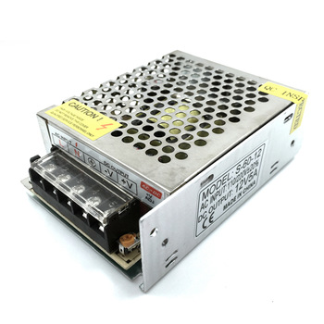

**12 volts SMPs.**

**Extra Hardware Requirements:**

**1.Soldering machine:**

Soldering is used to form a permanent connection between electronic components. The metal to be soldered is heated with a soldering iron and then solder is melted into the connection.

**2.Drill machine:**

A drilling machine, called a drill press, is used to cut holes into or through metal, wood, or other materials. Drilling machines use a drilling tool that has cutting edges at its point.

**3. Glue gun:**

Hot melt adhesive (HMA), also known as hot glue, is a form of thermoplastic adhesive that is commonly sold as solid cylindrical sticks of various diameters designed to be applied using a hot glue gun.

**4.Nuts and Bolts:**

Bolts and nuts are used in several applications, with a primary function to hold things or components together. (Joining various Components of 3D Printer).

**5.Aluminium Plates:**

Aluminium Plates is used to make the overall framework or used for formation of a frame of 3D printer.

**6.Cutter:**

Cutter is used for cutting various components of 3D Printer and Aluminium plates used in 3D Printer.**CONCEPTUAL MODELS**

* 1. **Entity Relationship Model**

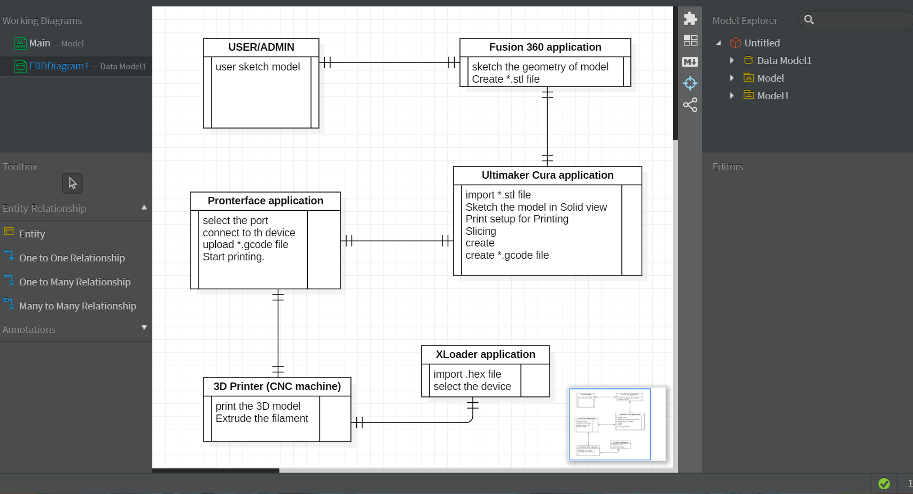

ER Model is used to model the logical view of the system from data perspective which consists of these components:

**Entity, Entity Type, Entity Set –**

An Entity may be an object with a physical existence – a particular person, car, house, or employee – or it may be an object with a conceptual existence – a company, a job, or a university course.

An Entity is an object of Entity Type and set of all entities is called as entity set. e.g.; E1 is an entity having Entity Type Student and set of all students is called Entity Set.

* 1. **USE CASE DIAGRAM**

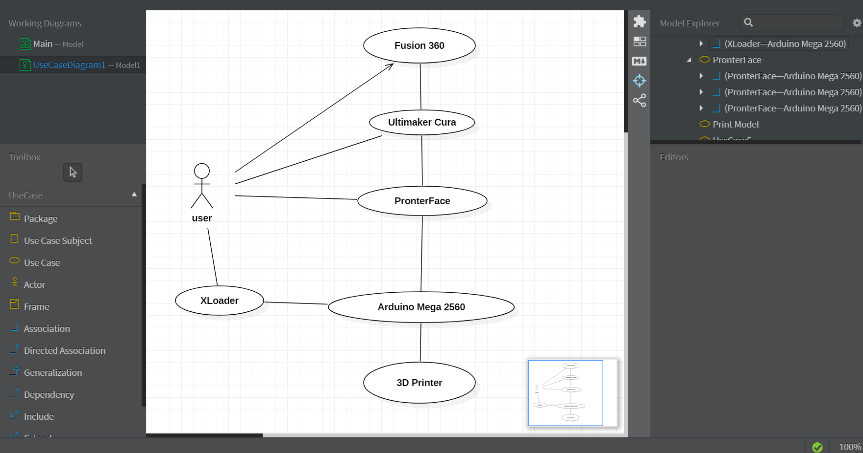

### **Explanation:**

A use-case model is a model of how different types of users interact with the system to solve a problem.  As such, it describes the goals of the users, the interactions between the users and the system, and the required behavior of the system in satisfying these goals.A use-case model consists of a number of model elements.  The most important model elements are: use cases, actors and the relationships between them.

A use-case diagram is used to graphically depict a subset of the model to simplify communications.  There will typically be several use-case diagrams associated with a given model, each showing a subset of the model elements relevant for a particular purpose.  The same model element may be shown on several use-case diagrams, but each instance must be consistent.  If tools are used to maintain the use-case model, this consistency constraint is automated so that any changes to the model element (changing the name for example) will be automatically reflected on every use-case diagram that shows that element.

The use-case model may contain packages that are used to structure the model to simplify analysis, communications, navigation, development, maintenance and planning.

Much of the use-case model is in fact textual, with the text captured in the [Use-Case Specification](http://www.utm.mx/~caff/doc/OpenUPWeb/openup/guidances/templates/uc_specification_E97E98B0.html)s that are associated with each use-case model element. These specifications describe the flow of events of the use case.

The use-case model serves as a unifying thread throughout system development. It is used as the primary specification of the functional requirements for the system, as the basis for analysis and design, as an input to iteration planning, as the basis of defining test cases and as the basis for user documentation

### **Basic model elements:**

The use-case model contains, as a minimum, the following basic model elements.

#### Actor

A model element representing each actor. Properties include the actors name and brief description. See [Concept: Actor](http://www.utm.mx/~caff/doc/OpenUPWeb/openup/guidances/concepts/actor_411726C.html) for more information.

#### Use Case

A model element representing each use case. Properties include the use case name and use case specification. See [Artifact: Use Case](http://www.utm.mx/~caff/doc/OpenUPWeb/openup/workproducts/use_case_22BE66E2.html) and [Concept: Use Case](http://www.utm.mx/~caff/doc/OpenUPWeb/openup/guidances/concepts/use_case_BB199D1B.html) for more information.

#### Associations

Associations are used to describe the relationships between actors and the use cases they participate in. This relationship is commonly known as a “communicates-association”.

**CHAPTER 4:**

**SYSTEM DESIGN**

**Algorithm Design:**

**START**

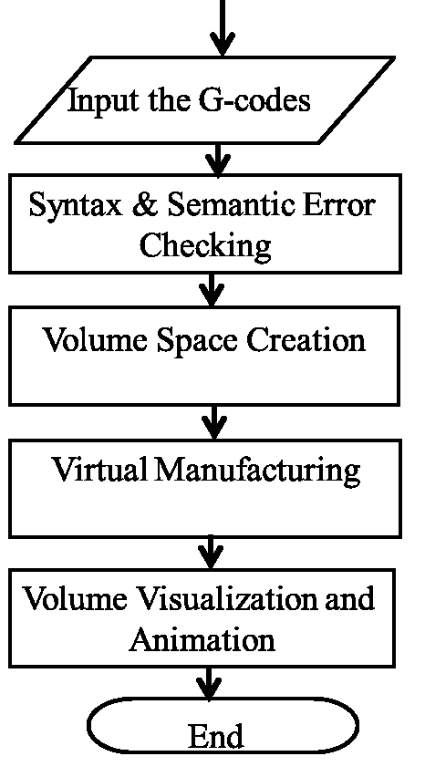

**Fig: Flowchart of a 3D printing simulation**

**Explanation of The Algorithm Design:**

Three Dimensional (3D) printing technologies fabricate objects layer by layer. Complex parts, which are difficult to produce by using subtractive manufacture methods, can be created by using these technologies. In a 3D printing process, the digital geometrical description of the target model has to be converted into machine codes to direct the printer to manufacture the model. Since the machine codes are hard to comprehend, the shape, correctness, and accuracy of the printed model cannot be known to the users beforehand. In a simulation program is presented to virtually emulate 3D printing to prevent errors and to preview printed results. In a simulation, the simulator fetches the machine codes from a disk file into the main memory and examines the machine codes line by line to detect syntax and semantic errors. Then, the simulator virtually manufactures the target model in a volume space. Since the virtual model is comprised of voxels, it resembles the target object better than conventional line-based models. As the virtual manufacture has completed, volume rendering and other graphics techniques are utilized to explore the exterior appearance as well as the interior structures of the virtual model. Thus, our simulation program reveals more details than conventional 3D printing simulators, and the fidelity and capability of the simulation are enhanced.

**Operation For 3D Printer**

**SOFTWARE OPERTATION**

**Open Fusion 360:**

1. Select and Object for Printing.

## Select Sketch Geometry to move.

1. Select Sketch Loft Inputs.
2. Export the Sketch Diagram And Object. (Convert the Selected body to a mesh body and outputs to STL or a 3D-Print Utility).
3. Select the body to output. Set the mesh controls and specify the print utility to output to.
4. Then later save the file into STL or (*.stl).

**Open Ultimaker Cura:**

1. Open the saved *.stl files.
2. Use Snap rotation to set the object accordingly.
3. Select the (Move(T)), and set the.

x-plane to zero.

y-plane to default size of the object.

z-plane to zero.

1. Select the view, from layer view to solid view.
2. Select the Print Setup.
3. Use Recommended setting for beginners.

(Print with the recommended settings for the selected printer, materials and quality).

1. Custom setting for Professionals.
2. Click on Prepare for Slicing.
3. Save to Removable Drive. (Select the Drive).
4. Save the File in G-Code file(*.gcode).

**Open XLoader:**

1. Select the hex. File from Firmware Folder.
2. Select the Device where you want to upload.
3. Click on Upload.

**Open Pronterface:**

1. Select the Port printer is connected to.
2. Click on the Connect (Connect to the printer).
3. Load a 3D model File(.gcode file).
4. Click on start to start the printing.

**HARDWARE OPERATION**

**Motoring:**

The operating of 3D printer requires motoring with low torque, high accuracy the best motor to do this function is stepper motor: is an electromagnetic device that converts digital pulses into mechanical shaft rotation. Advantages of step motors are low cost, high reliability, high torque at low speeds and a simple they are a special type of synchronous motors which are designed to rotate a specific number of degrees for every electric pulse received by its control unit, a fraction of degree could be done using gears in order to move the printer head a specific displacement, in 3D printer four stepper motors were needed to do the specific function, three of them were used for moving in X,Y,Z direction of the printer head, the 4th one was needed to move the plate(bed).

**Processing:**

The microcontroller Arduino Mega will get the commands from the Laptop/pc to the Port it is connected to. The Microcontroller will further transfer the electrical signals to the Stepper Motor Connected to X,Y and Z plane. The X,Y and Z plane will move according to the commands or code to print the object or element(3D object).

**SECRUITY ISSUES:**

**Harmful Emissions:**

3D printers used in enclosed places such as homes can generate potentially toxic emissions and carcinogenic particles according to researchers at the Illinois Institute of Technology. Their 2013 research [study](http://pubs.acs.org/doi/pdf/10.1021/acs.est.5b04983) showed that 3D desktop computers could emit large numbers of ultrafine particles and some hazardous volatile organic compounds during printing. The printers emitted 20 billion ultrafine particles per minute using PLA filament, and the ABS emitted up to 200 billion particles per minute. Emitted radiations are similar to burning a cigarette, and may settle in the bloodstream or lungs posing health risks including cancer and other ailments.

**Too Much Reliance on Plastic:**

Popular and cheap 3D printers use a plastic filament. Although using raw plastic reduces waste generation, the machines still leave unused or excess plastic in the print beds. [PLA](https://3dinsider.com/pla-3d-printing-filaments/) is biodegradable, but [ABS filament](https://3dinsider.com/abs-3d-printing-filaments/) is still the most commonly used type of plastic. The plastic by-product ends up in landfills negatively affecting the environment. Furthermore, plastic limits the type of products that can be created from the material. Future 3D printers will need to use other materials such as metal (as some currently do) or carbon composites to become more useful to manufacturers and consumers alike.

**Manufacturing Job Losses:**

3D printing technology can make product designs and prototypes in a matter of hours as it uses only one single step. It eliminates a lot of stages that are used in subtractive manufacturing. As a result it doesn’t require a lot of labor cost. As such, adopting 3D printing may decrease manufacturing jobs. For countries that rely on a large number of low skill jobs, the decline in manufacturing jobs could dramatically affect the economy. It’s likely that robotics will have a much larger impact here.

**Copyright Infringements:**

Counterfeiting is one the most significant disadvantages of 3D printing. Anyone with a product blueprint can forge products very quickly. Patent violations will increasingly become more common, and identifying counterfeited items will become practically impossible. As 3D printing technology evolves, patents, and copyright holders will have a harder time protecting their rights and companies manufacturing unique products will be significantly affected.

**Production of Dangerous Weaponry:**

With 3D printers, it is easy to create 3D knives, guns, explosives, and any other dangerous items. Criminals and terrorists can, therefore, make such weapons without being detected. Some criminal organizations have already used 3D printing technology to create card readers for bank machines. As time goes on, 3D technology will become more user-friendly and cost-effective, and it is possible that design and production of unlicensed weaponry will increase.

# Threat 3-D Printing Could Pose To Global Security:

In 2016, an international team of cybersecurity researchers hacked into a computer that contained the design blueprints for a drone propeller. They [tampered with a few lines of code](https://www.sciencedaily.com/releases/2016/10/161020132450.htm), sent the file to be 3-D printed and installed the faulty part on a $1,000 drone. Within a few minutes of takeoff, the drone malfunctioned and came crashing down to Earth.

The experiment was designed to show how the malicious manipulation of 3-D blueprints can lead to mechanical failure. In this case, the researchers had introduced 0.1mm cavities into the propeller’s blades, leading it to disintegrate in midair. The tiny holes were invisible to the naked eye, and the flawed propeller looked identical to its three functioninag counterparts.

As major aerospace companies, including Boeing and Airbus, begin to [incorporate 3-D printed parts](https://www.reuters.com/article/us-norsk-boeing-idUSKBN17C264) into their commercial aircraft, should the public be worried about this scene playing out on a larger scale? According to a [new report from the RAND Corporation](https://www.rand.org/pubs/perspectives/PE283.html), a global policy think tank, 3-D printing could be a serious threat to global security. And it’s time for policymakers to start thinking about how to prevent disaster.

**CONCLUSION**

As the 3D printer is a device, it should be analysed with the advantages and disadvantages, how the device can change the society and engineering etc in mind. The very nature of 3D printing, creating a part layer by layer, instead of subtractive methods of manufacturing lend themselves to lower costs in raw material. Instead of starting with a big chunk of plastic and carving away (milling or turning) the surface in order to produce your product. Additive manufacturing only "prints" what you want, where you want it. Other manufacturing techniques can be just as wasteful. 3D printing is the ultimate just-in-time method of manufacturing. No longer do you need a warehouse full of inventory waiting for customers. Just have a 3D printer waiting to print your next order. On top of that, you can also offer almost infinite design options and custom products. It doesn't cost more to add a company logo to every product you have or let your customers pick every feature on their next order, the sky is the limit with additive manufacturing.

Whether you are designing tennis shoes or space shuttles, you can't just design whatever you feel like, a good designer always take into account whether or not his design can be manufactured cost effectively. Additive manufacturing open up your designs to a whole new level. Because undercuts, complex geometry and thin walled parts are difficult to manufacture using traditional methods, but are sometimes a piece of cake with 3D printing. In addition, the mathematics behind 3D printing are simpler than subtractive methods. For instance, the blades on a centrifugal supercharger would require very difficult path planning using a 5-axis CNC machine. The same geometry using additive manufacturing techniques is very simple to calculate, since each layer is analysed separately and 2D information is always simpler than 3D. This mathematical difference, while hard to explain is the fundamental reason why 3D printing is superior to other manufacturing techniques. It almost always better to keep things simple and additive manufacturing is simple by its very nature.

With so many potential benefits of 3D printing, there’s no surprise that this method is making its way through a diverse number of industries and quickly becoming a favourite tool of progressive marketers.

Comparing the numerous advantages, applications and future scope, we can conclude that the 3D printer and its technology is able to create next industrial revolution.

**BIBLIOGRAPHY**

**Books:**

• The Book on 3D Printing Paperback – August 31, 2013

By Isaac Budmen

• 3D Printing: The Next Industrial Revolution Paperback – May 4, 2013

By Christopher Barnatt

• Fabricated: The New World of 3D Printing Paperback – February 11, 2013

By Hod Lipson

**Links:**

• www.3dprinting.com

• www.3dprinter.net/reference

• www.3dprintingindustry.com

• www.stratasys.com/applications

• www.en.wikipedia.org/wiki/3D_printing

• www.3ders.org/3d-print-technology.html

• www.zdnet.com/how-3d-printing-is-building-a-new-future-7000032248